Handout
Stomach/Belly Breathing

Stomach/Belly Breathing

Deep breathing is one of the best ways to lower stress in the body. It sends a message to your brain to calm down and relax and your brain sends that same message to your body. For this exercise you can sit or lie down.

Make sure you are comfortable. Place your hand gently on your abdomen right below your ribcage. Feel the warmth of your hand against your belly. Inhale slowly and deeply through your nose and push the air into the bottom of your lungs into the deepest part of your belly. You will feel your stomach moving your hand if you are breathing into your belly.

Once you have inhaled fully, pause for a few moments and then exhale fully through your nose or your mouth -- whichever is more comfortable. As you exhale, allow your whole body to relax and go limp.

Now you can build on that. I want you to count to four in your head as you breathe in…pause and hold that breath for two counts…Count to four as you breathe out….pause for two counts with no breath.

Remember, count to four as you breathe in, pause for two counts while holding your breath, count to four while breathing out, and pause for two counts.

That whole thing equals one breath. Do ten full breaths. Count how long you are holding each part of your breath – the inhale for four counts, hold for two counts, exhale for four counts, and hold with no breath for two counts.

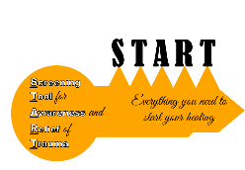

©2014 Nicky MacCallum LMFT,NCC and Youth ALIVE!
Contact nmaccallum@youthalive.org for reprinting

Version 1/22/16

